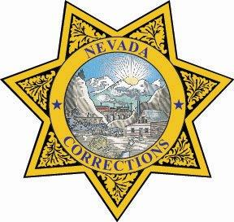
STATE OF NEVADA
Department of Corrections

Acting PIO W.C. “Bill” Quenga: wquenga@doc.nv.gov

Press Release
For Immediate Release:
April 23, 2021

Inmate walkaway captured

An inmate who walked away from Stewart Conservation Camp in south Carson City on Friday morning was captured less than an hour later near Topsy Lane.

Aaron Aipoalani, #1210362, was determined missing at 7:50 a.m. Friday and was apprehended around 8:25 a.m. after a tip from a Nevada Dept. Of Corrections employee who reported seeing a man dressed in prison blues in the area.

Aipoalani, 29, was serving 2-13 years for grand larceny and burglary.


